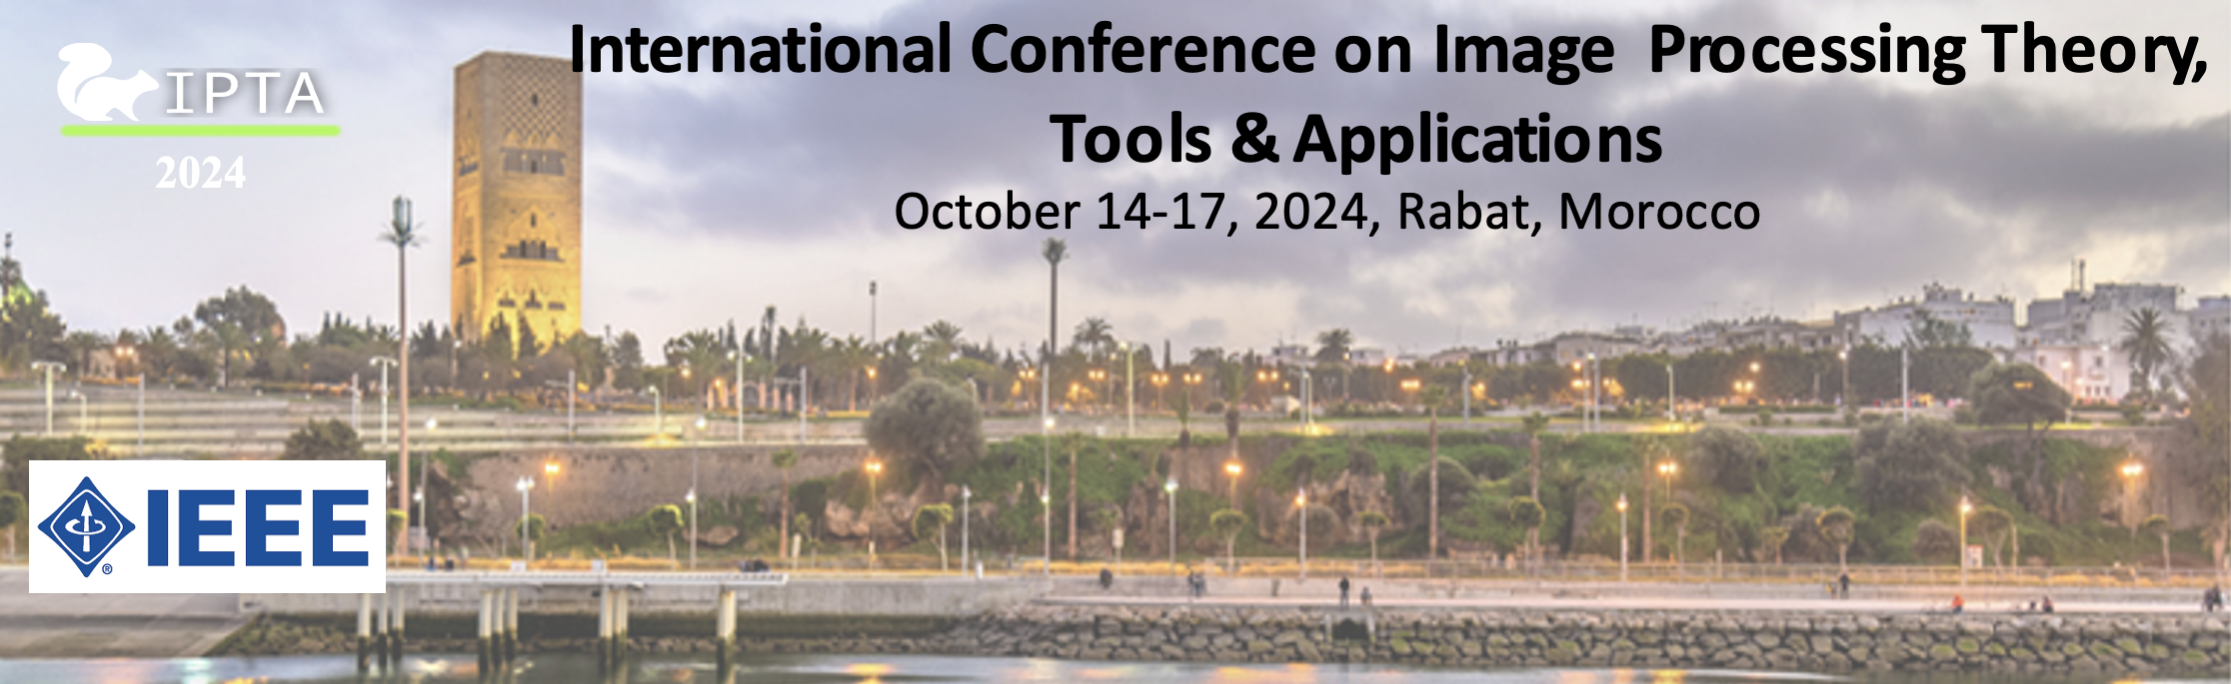
Special session title:

<title>

Brief description of the proposed topic (150-300 words):

<description>

Potential contributions:
- <Contribution 1: authors, preliminary title>
- <Contribution 2: authors, preliminary title>
- …

Email(s) of chairs :
- <First and Last Name 1 (email)>
- <First and Last Name 2 (email)>

Proposals must be sent by April 15th as a single PDF file to:
- Lucas Krasula (USA) lkrasula@netflix.com
- Lahoucine Ballihi (Morocco) lahoucineinfo@yahoo.fr
- Mourad Oussalah (Finland) mourad.oussalah@oulu.fi
- Aladine Chetouani (France) aladine.chetouani@univ-orleans.fr
- Mohamed El Hassouni (Morocco) mohamed.elhassouni@flsh.um5.ac.ma

Special Session Chairs:

First and Last Name
Institution and Laboratory…
email

First and Last Name
Institution and Laboratory…
email
….

