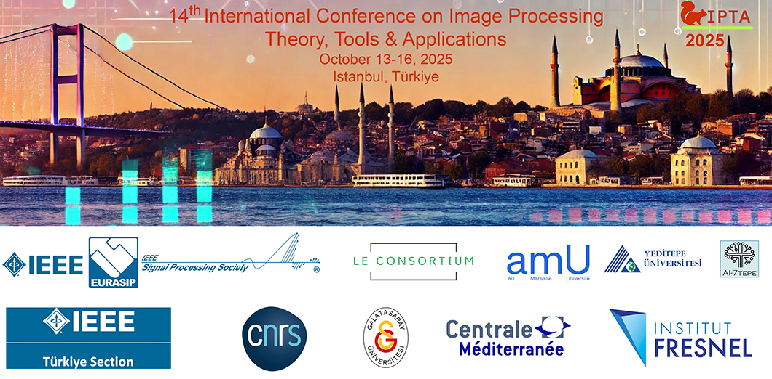
Special Session Chairs:

First and Last Name
Institution and Laboratory…
email

First and Last Name
Institution and Laboratory…
email
….

Special session title:

<title>

Brief description of the proposed topic (150-300 words):

<description>

Potential contributions:
- <Contribution 1: authors, preliminary title>
- <Contribution 2: authors, preliminary title>
- …

Email(s) of chairs :
- <First and Last Name 1 (email)>
- <First and Last Name 2 (email)>

Proposals must be sent by April 15th as a single PDF file to:
- Djamal MERAD djamal.merad@univ-amu.fr
- Régine LE BOUQUIN JEANNES regine.le-bouquin-jeannes@univ-rennes.fr
- Mouloud ADEL Mouloud.adel@univ-amu.fr

